**README:** location_name was a number(3,0), that didn’t make sense so i made it a varchar. Code would not run in oracle for some reason I couldn’t figure out, so I made all the tables in the GUI just now.

Fitclass was a (9,0) everywhere but one place, do we want it to be 9 or 3? I made it 9 for now. We were doing the tables wrong originally daibo, you don’t have to have an identity box checked to proceed.

Edit/Daibo: Keep it as 9

I had to go back and fix some tables, you can still populate from a referenced identity column. I double and triple checked all my tables before copy pasting the code from the object browser into here. Pasted into the team assignment, deleted from here.

Usernames, accounts and passwords: ACTIVE

My workspace: PSU_010

Astan_D, [apd5545@psu.edu](mailto:apd5545@psu.edu), “Qu1et12”

Daibo_Z, [dvz5048@psu.edu](mailto:dvz5048@psu.edu), “wutisprocedur4l”

Purna_B,pbb5119@psu.edu, “Graph1csmyj4m”

Purna: I had create the GYM DATABASE APPlICATION in workspace. This is phase 1 of seven phase in videos. I finished creating one page master detail table: timslot and fitness as fitness and timeslot, memberplan and client as Fitness and timeslot.

One to many relationship(Table name is inside parenthesis)

**Merchandise ClientMerchandise (Merchandise and clients)**

**Client ClientMerchandise (Client and merchandise)**

**Memberplan Client(Member Plan and clients)**

**Client FitClassClient (Client and fitness class clients)**

**FitClass** **FitClassClient (Fitness class and clients)**

**Timeslot**  **FitClass (Timeslot and fitness class)**

**FitClass FitClassLocation (Fitness class and location)**

**Location FitClassLocation (location and fitness class)**

**FitClass** **FitClassInstructor (Fitness class and instructor )**

**Instructor FitClassInstructor (Instructor and fitness class)**

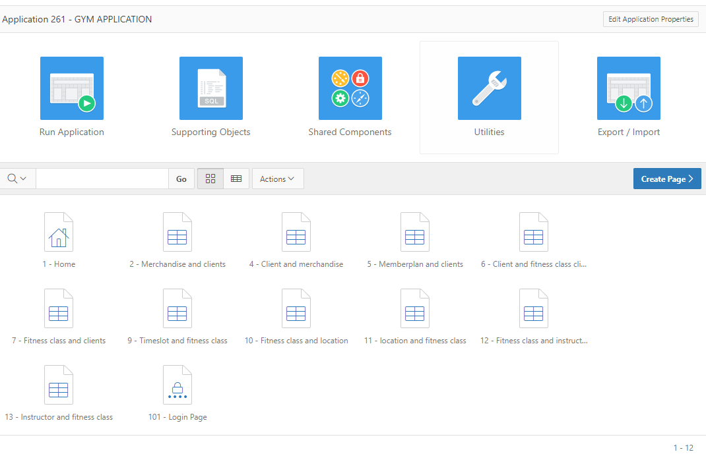

**Purna: I have done creating table. You guys now insert the data into tables.**

**Astan:**

Membership Plans- Standard & Premium

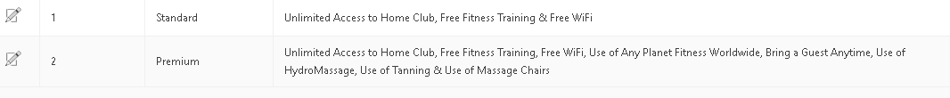

Clients: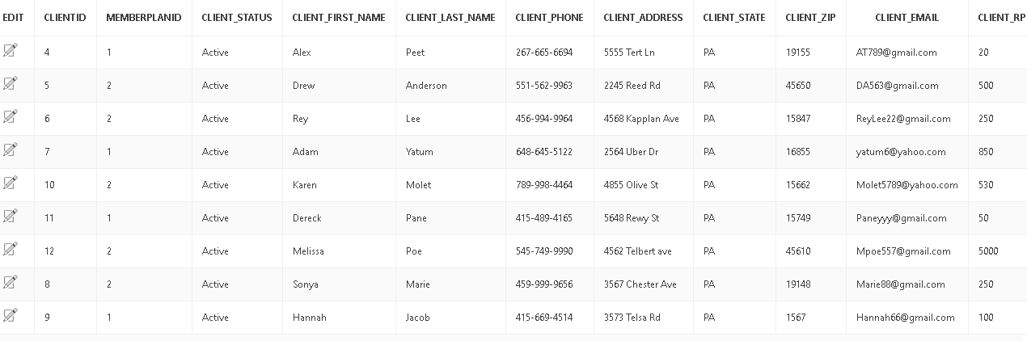

Merchandise-

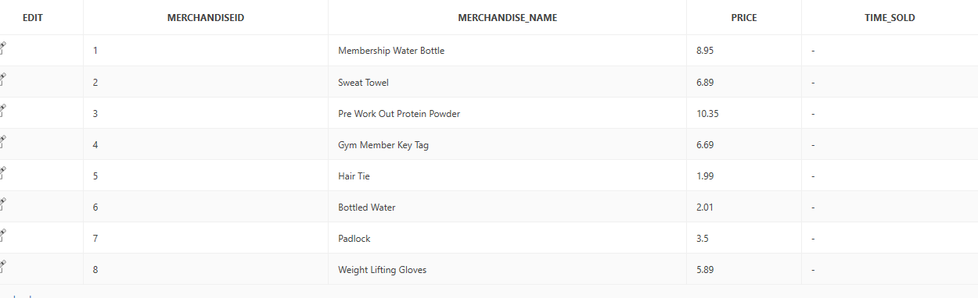

Client Merchandise-

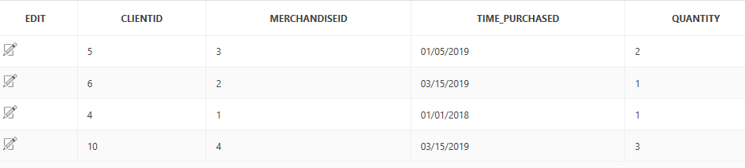

Timeslot-

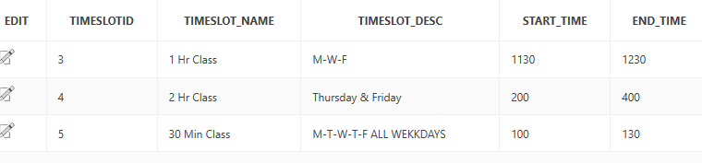

Fit Classes

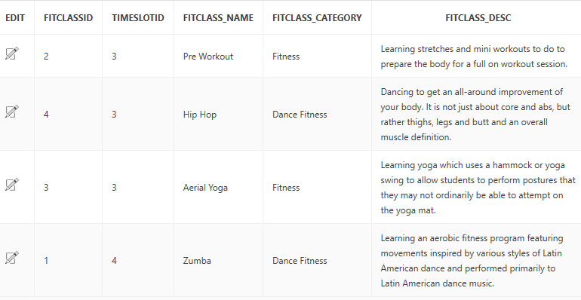

Fit Class Client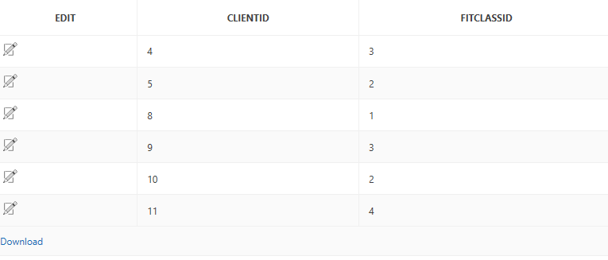

Locations

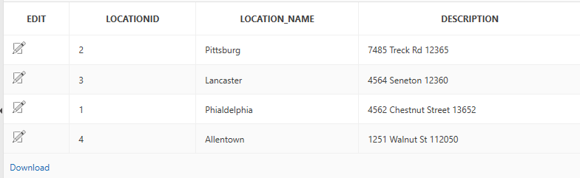

Fit Class Location

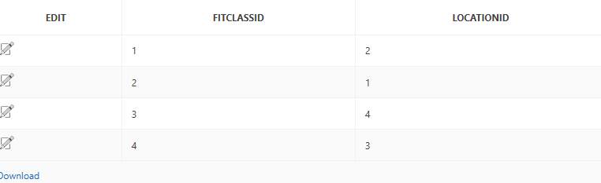

Instructors

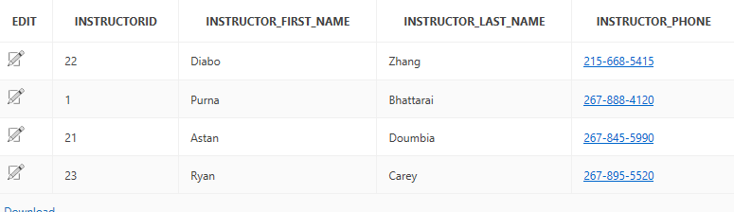

Class Instructors

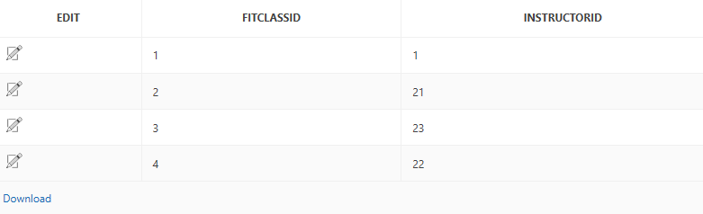

Purna: We need to have select list on the table that has foreign key which is not a primary key of table as shown in video 6.

Purna;Update on (client and merchandise ,client and fit class client) so I filter out with memberplanid with 1 for standard and 2 for premium